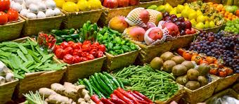

**EAT THESE ANTI-INFLAMMATORY FOODS**

* Seasonal fresh fruit and vegetables
* Green leafy vegetables including spinach, kale, rocket, brussel sprouts
* Berries
* Non-gluten containing whole grains (e.g. buckwheat, oats, brown rice, quinoa)
* Legumes (e.g. beans, lentils)
* Omega-3 rich foods: Oily fish (salmon, herring, sardines), walnuts, macadamias, chia seeds, green lipped mussels
* Healthy fats: extra virgin olive oil, coconut oil, sesame seed oil, avocado oil
* Ginger - in cooking, juices or as a tea
* Turmeric - in cooking, juices, or as a tea

**AVOID THESE PRO-INFLAMMATORY FOODS**

* Trans and oxidised fats (fried foods, processed foods, foods cooked in vegetable oil)
* Gluten (wheat, spelt, rye, barley)
* Dairy (cheese, milk)
* Sweet corn
* Processed, packaged, and refined foods
* Red meat, especially grain-fed
* Simple/refined carbohydrates (white/raw sugar, sweets, soft drink, corn syrup, food/drink with added sugar)
* Caffeine (coffee, tea, energy drinks)
* Alcohol

# **EATING TO REDUCE INFLAMMATION**

# Systemic inflammation (low-grade inflammation throughout the body) may contribute to chronic health problems, including diabetes, cardiovascular disease, arthritis, allergies, cancer, digestive issues, fatigue, autoimmune disease, hormone imbalances, and thyroid disease. Eating an unprocessed diet rich in whole foods can help to reduce this inflammation.